**Teaching Assistant Class 18/9/19**

**Gadtardi Wongkaren 2301929480**

**Student Names Program**

1. **Add Student**

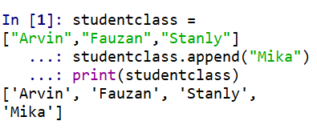

1. **Edit Name**

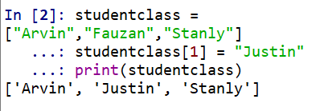

1. **Remove Student**

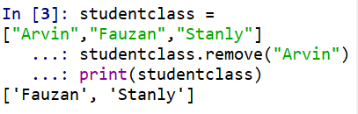

1. **Search Student**

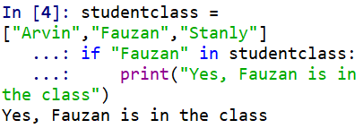

1. **Print all name**

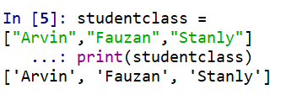

1. **Count number of students**

